

**CERTIFICATE OF SPECIFIC LEARNING DIFFICULTY**

**…………………….**

**Student ID number:** 1008015

**Student:** Mohammod Habibur Rahman

This certificate must be copied and put on the front of all assignments and examinations.

This Certificate is for your use only. Any modification or misuse is a breach of university regulations.

**Assessors and Examiners:**

This certifies that this student has been assessed as a person with specific learning difficulties. In marking, try to look beyond the poor language skills for knowledge, content and ideas, **unless written language and communication skills are essential learning outcomes.**

**Students must be fully aware that any adjustments do not override prescribed professional standards required in their course.**

**For further information on marking guidelines please look on the DDAC website:**

<http://www.uel.ac.uk/studentservices/supportingyou/staff/index.htm>

**Signed:** 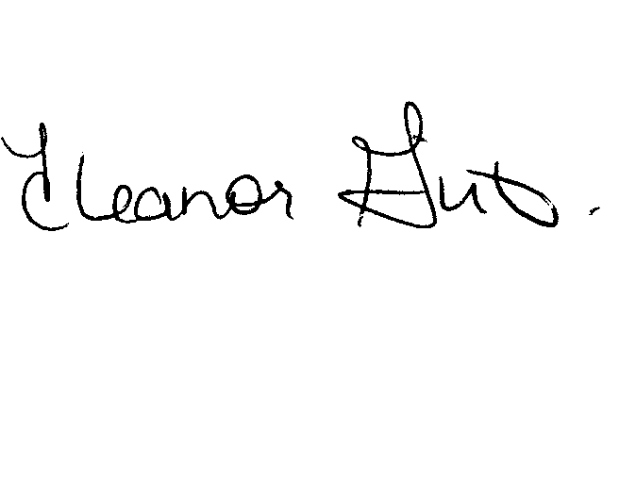

**Name: Eleanor Girt, Head of Disability/Dyslexia and Access Centre**

**Date: 23 November 2012**



**Advanced Database System**

**Module code: SD3042**

**Institution**: University Of East London (UEL)

Mohammod Habibur Rahman

**ID**: u1008015

Alexandros Akrivopoulos-Hughes

**ID:** u1235441

**Module Leader: Juliette Alfred-Lewar**

Glossary

Table of Contents

1.0 Case Study 4

1.1 Introduction 4

1.2 Database Modelling and Implementation: 5

1.3 ER1 10

1.4 ER2 12

1.5 Listing of the records in each table 13

1.6 PL/SQL 14

1.7 Implementation 15

1.8 Showing the Queries 17

1.9 Group Member Participation 19

2.0 Evaluation 21

2.1 Recommendation 22

2.2 References 23

# 1.0 Case Study

In this assessment we have been told that a company called Natural Health Shop wants us to develop them a booking system for the company which was implemented as a relational database which contains some business logic functionality, as they were having problems making orders and were also double booking rooms. Therefore this company had approached us in good faith and has asked us to design and implement for them, a database. They don’t want the whole system to take over the shop, but allow the employees not to double book rooms and also they can have a system where they can see how the exact condition of the stock so they don’t need to order more than what is needed. Therefore we, as a team will extract the business rules of the company and present them a design as well as a demo implementation of the system.

# 1.1 Introduction

Our group will design and develop a database for a Natural Health Shop to help the staff to run the shop more efficiently.

In order to develop a useful system we will have to fully understand and keep in mind the business rules of the company, create an ER1, a logical model, where we can define the entities, attributes and relationships between them. After that the flow of work will proceed by converting the logical model to a relational model etc.

The DBMS (database management system), must be able to cope with some of the questions which are important to the business.

We will be using Oracle DBMS as the platform to develop our database management system for the company.

Before we start developing this database management system we must think of what each person must do. Once everybody has been assigned his part of work, we will then start to build the DBMS one part at a time. We will also make sure that when we are creating the DBMS we are taking into consideration that the DBMS can carry out some simple tasks which the business needs from the system. Oracle will be used in this case to provide the database management system (DBMS) which will help us into programming the business logic using PL/SQL.

We as a group will be working hard into developing consistent, scalable and efficient system to help the staff to keep the business running. We will also create some close to reality sample data in order to run business scenarios and investigate if the system can really respond to the company’s needs.

# 1.3 ER1

This is the ER1 which we developed and demonstrates the logical model of the company.

Figure : ER1

The relationships between entities can be fully demonstrated using 1..* (one to many), *..*(Many to Many) or 1..1(One to One) relationships.

If we forward engineer the logical model appearing in ERD1, along with some modifications, we will get the ERD2.

**A brief description of the relationships is given below:**

1. Each **Product** *is supplied* by many **Suppliers**  
   Each **Supplier** *supplies* many **Products**
2. Each **Supplier** *supports* many **Shops**  
   Each **Shop** *is supported* by many **Suppliers**
3. Each **Product** *exists* in many **ShopOrders**  
   Each **ShopOrder** *contains* many **Products**
4. Each **ShopOrder** *belongs* to one **Shop**  
   Each **Shop** *contains* many **ShopOrders**.
5. Each **Product** *has* many **Stocks**  
   Each **Stock** *contains* one **Product**
6. Each **Stock** *belongs* to one **Shop**  
   Each **Shop** *contains* many **Stock items**
7. Each **Stock** *is used* by many **Inventory items**  
   Each **Inventory** *uses* one **Stock item**
8. Each **Inventory** *is used* by one **Treatment**  
   Each **Treatment** *uses* many **Inventory items**
9. Each **Shop** *contains* many **Rooms**  
   Each **Room** *is located* at one **Shop**
10. Each **Shop** *has* many **Employees**  
    Each **Employee** *works* in one **Shop**
11. Each **Shop** *manages* many **Employees**  
    Each **Employee** *is managed* by one **Shop**  
    Each **Shop** *is managed* by one **Employee**
12. Each **Employee** possesses many **Specialties**  
    Each **Specialty** can be possessed by many **Employees**
13. Each **Employee** *serves* on many **Bookings**  
    Each **Booking** *is served* by one **Employee**
14. Each **Room** *is booked* by many **Bookings**  
    Each **Booking** *uses* one **Room**
15. Each **Treatment** *exists* in many **Bookings**  
    Each **Booking** *operates* one **Treatment**
16. Each **Customer** *is served* in many **Bookings**  
    Each **Booking** *is booked* by one **Customer**

## 1.2 Database Modelling and Implementation:

**Main entities of Natural Health Shop**

* Product
* Supplier
* ShopOrder
* Stock
* Shop
* Inventory
* Employee
* Room
* Treatment
* Speciality
* Booking
* Customers

*These are our 12 entities for the company which we think they need reading their requirements.*

# 1.4 ER2

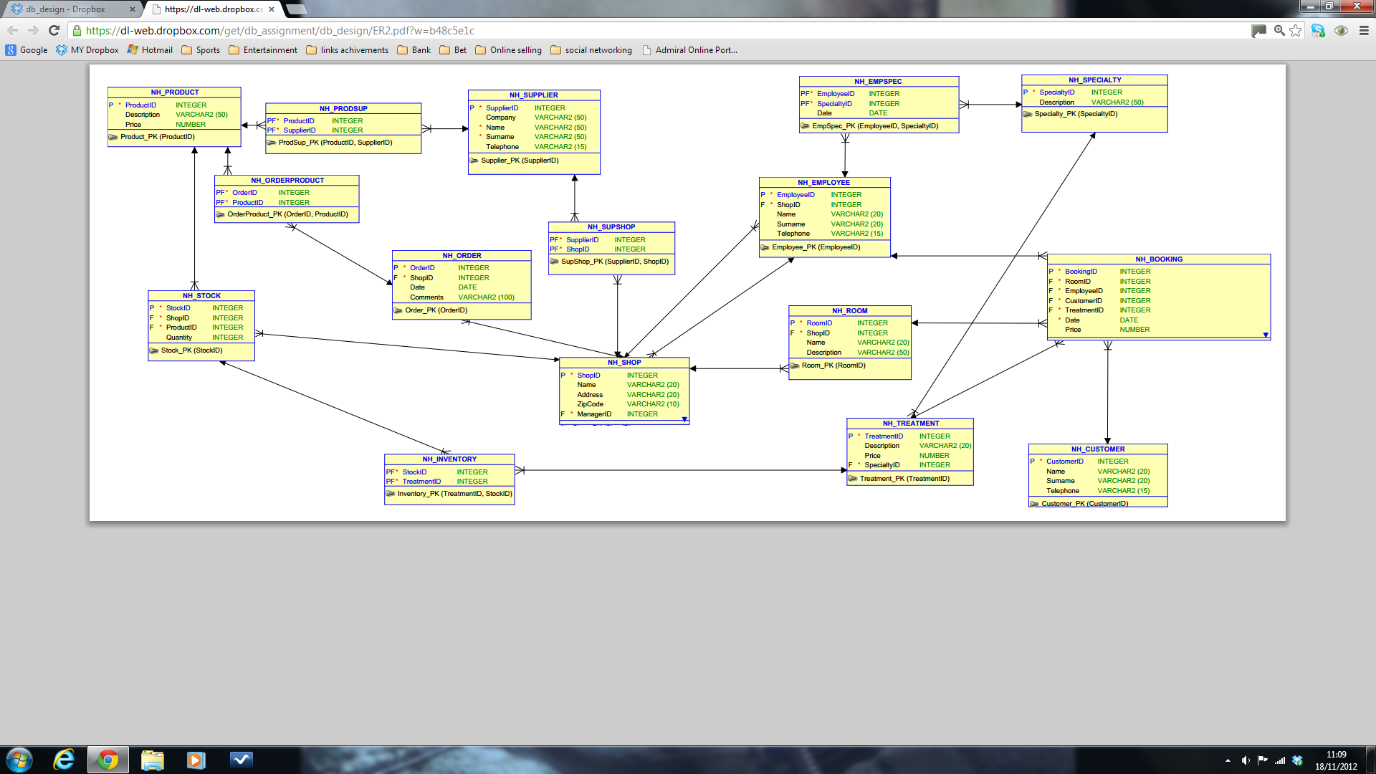

Do some forward engineering the Logical Model appearing in the ER1 and we get ER2. One can also see in the diagram some of the constraints that are to be applied on the database tables.

# 1.5 Listing of all the tables

**NH_BOOKING Table Structure**

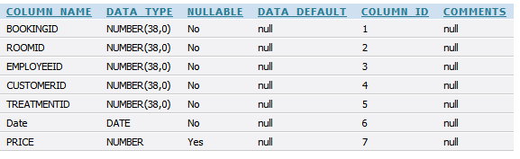

**NH_BOOKING Table Constraints**

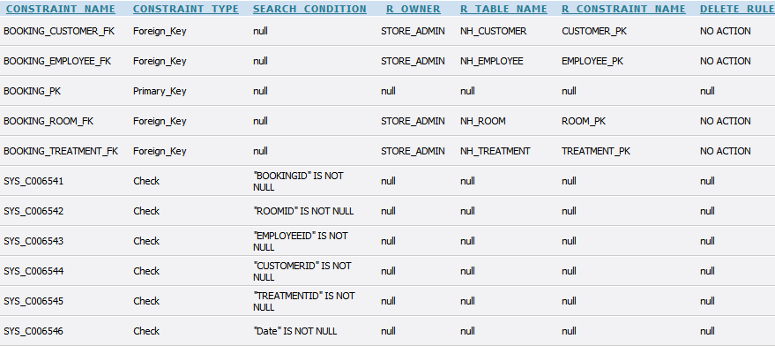

**NH_BOOKING Creation, Population and Constraint Script**

CREATE TABLE NH_BOOKING

(

BookingID INTEGER NOT NULL ,

RoomID INTEGER NOT NULL ,

EmployeeID INTEGER NOT NULL ,

CustomerID INTEGER NOT NULL ,

TreatmentID INTEGER NOT NULL ,

"Date" DATE NOT NULL ,

Price NUMBER

)

;

ALTER TABLE NH_BOOKING

ADD CONSTRAINT Booking_PK PRIMARY KEY ( BookingID ) ;

/* BookingID INT, RoomID INT, EmployeeID INT, CustomerID INT, TreatmentID INT, Date DATE, Price DECIMAL */

INSERT INTO NH_BOOKING VALUES

(1, 1, 1, 1, 1, '04-JUL-2010', 50.2);

INSERT INTO NH_BOOKING VALUES (2, 11, 12, 14, 11, '04-JUL-2011', 45);

INSERT INTO NH_BOOKING VALUES (3, 4, 2, 4, 6, '05-JUN-2012', 70);

INSERT INTO NH_BOOKING VALUES (4, 7, 4, 6, 8, '04-SEP-2013', 85);

INSERT INTO NH_BOOKING VALUES (5, 2, 10, 5, 9, '13-JUL-2012', 90);

INSERT INTO NH_BOOKING VALUES (6, 4, 9, 3, 5, '30-AUG-2012', 54);

INSERT INTO NH_BOOKING VALUES (7, 12, 5, 7, 3, '11-JUL-2011', 44);

INSERT INTO NH_BOOKING VALUES (8, 13, 3, 8, 6, '25-SEP-2011', 40);

INSERT INTO NH_BOOKING VALUES (9, 11, 1, 2, 12, '19-JUL-2010', 39.99);

INSERT INTO NH_BOOKING VALUES (10, 10, 14, 8, 6, '20-OCT-2012', 49.99);

INSERT INTO NH_BOOKING VALUES (11, 1, 11, 5, 8, '17-JUL-2012', 59.99);

INSERT INTO NH_BOOKING VALUES (12, 4, 5, 11, 13, '11-JUL-2011', 43.3);

INSERT INTO NH_BOOKING VALUES (13, 7, 3, 10, 12, '11-JUL-2011', 117);

INSERT INTO NH_BOOKING VALUES (14, 8, 7, 12, 10, '04-JUL-2012', 65.4);

INSERT INTO NH_BOOKING VALUES (15, 2, 8, 14, 5, '12-DEC-2011', 23.6);

INSERT INTO NH_BOOKING VALUES (16, 7, 2, 4, 6, '14-SEP-2012', 32.3);

INSERT INTO NH_BOOKING VALUES (17, 4, 4, 2, 2, '11-SEP-2008', 56.7);

INSERT INTO NH_BOOKING VALUES (18, 12, 11, 8, 7, '16-JUL-2010', 55);

INSERT INTO NH_BOOKING VALUES (19, 13, 6, 15, 1, '18-JUL-2010', 42);

INSERT INTO NH_BOOKING VALUES (20, 1, 3, 1, 12, '20-JUL-2010', 49.99);

ALTER TABLE NH_BOOKING

ADD CONSTRAINT Booking_Customer_FK FOREIGN KEY

(

CustomerID

)

REFERENCES NH_CUSTOMER

(

CustomerID

)

;

ALTER TABLE NH_BOOKING

ADD CONSTRAINT Booking_Employee_FK FOREIGN KEY

(

EmployeeID

)

REFERENCES NH_EMPLOYEE

(

EmployeeID

)

;

ALTER TABLE NH_BOOKING

ADD CONSTRAINT Booking_Room_FK FOREIGN KEY

(

RoomID

)

REFERENCES NH_ROOM

(

RoomID

)

;

ALTER TABLE NH_BOOKING

ADD CONSTRAINT Booking_Treatment_FK FOREIGN KEY

(

TreatmentID

)

REFERENCES NH_TREATMENT

(

TreatmentID

)

;

**NH_CUSTOMER Table Structure**

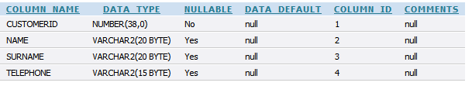

**NH_CUSTOMER Table Constraints**



**NH_CUSTOMER Creation, Population and Constraint Script**

CREATE TABLE NH_CUSTOMER

(

CustomerID INTEGER NOT NULL ,

Name VARCHAR2 (20) ,

Surname VARCHAR2 (20) ,

Telephone VARCHAR2 (15)

)

;

ALTER TABLE NH_CUSTOMER

ADD CONSTRAINT Customer_PK PRIMARY KEY ( CustomerID ) ;

/* CustomerID INT, Name VARCHAR, Surname VARCHAR, Telephone VARCHAR */

INSERT INTO NH_CUSTOMER VALUES

(1, 'aCustomerName', 'aCustomerSurname', '123456789');

INSERT INTO NH_CUSTOMER VALUES (2, 'aCustomerName2', 'aCustomerSurname3', '123456789');

INSERT INTO NH_CUSTOMER VALUES (3, 'Jack', 'New', '02089874563');

INSERT INTO NH_CUSTOMER VALUES (4, 'Ryan', 'ken', '0207589989');

INSERT INTO NH_CUSTOMER VALUES (5, ' Kai', 'roon', '02087414141');

INSERT INTO NH_CUSTOMER VALUES (6, 'rick', 'nick', '02082020232');

INSERT INTO NH_CUSTOMER VALUES (7, 'Adam', 'Ali', '0205255698');

INSERT INTO NH_CUSTOMER VALUES (8, 'Ray', 'milton', '02085478745');

INSERT INTO NH_CUSTOMER VALUES (9, 'milly', 'toof', '0208547457');

INSERT INTO NH_CUSTOMER VALUES (10, 'Brown ', 'Joe', '02087414141');

INSERT INTO NH_CUSTOMER VALUES (11, 'Lloyd', 'bank', '0208578785');

INSERT INTO NH_CUSTOMER VALUES (12, 'Fred', 'Eil', '02085488878');

INSERT INTO NH_CUSTOMER VALUES (13, 'Freddie', 'Elliot', '02085488878');

INSERT INTO NH_CUSTOMER VALUES (14, 'Bill', 'bush', '02085555893');

INSERT INTO NH_CUSTOMER VALUES (15, 'red ', 'coe', '02085412569');

INSERT INTO NH_CUSTOMER VALUES (16, 'Web', 'Ref', '02085411012');

**NH_EMPLOYEE Table Structure**

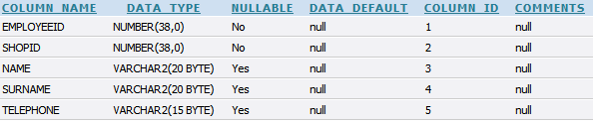

**NH_EMPLOYEE Table Constraints**

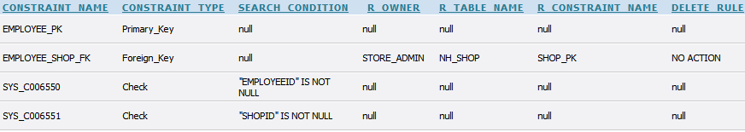

**NH_EMPLOYEE Creation, Population and Constraint Script**

CREATE TABLE NH_EMPLOYEE

(

EmployeeID INTEGER NOT NULL ,

ShopID INTEGER NOT NULL ,

Name VARCHAR2 (20) ,

Surname VARCHAR2 (20) ,

Telephone VARCHAR2 (15)

)

;

ALTER TABLE NH_EMPLOYEE

ADD CONSTRAINT Employee_PK PRIMARY KEY ( EmployeeID ) ;

/* EmployeeID INT, ShopID INT, Name VARCHAR, Surname VARCHAR, Telephone VARCHAR */

INSERT INTO NH_EMPLOYEE VALUES

(1, 1, 'anEmployeeName', 'anEmployeeSurname', '123456789');

INSERT INTO NH_EMPLOYEE VALUES (2, 1, 'Manager', 'Badass', '123456789');

INSERT INTO NH_EMPLOYEE VALUES (3,1, 'Employee', 'Tool', '123456789');

INSERT INTO NH_EMPLOYEE VALUES (4, 2, 'Foreigner', 'nbd wants him', '123456789');

INSERT INTO NH_EMPLOYEE VALUES (5, 2, 'Dwayne','Johnson', '02075122365');

INSERT INTO NH_EMPLOYEE VALUES (6, 2, 'Rey','Riley', '012254589651');

INSERT INTO NH_EMPLOYEE VALUES (7, 2, 'Kelly','Kelly', '01548596321');

INSERT INTO NH_EMPLOYEE VALUES (8, 3, 'Zack','Rider', '020714788741');

INSERT INTO NH_EMPLOYEE VALUES (9, 3, 'Alicia','Fox', '010136987456');

INSERT INTO NH_EMPLOYEE VALUES (10, 4, 'Mohammed', 'Ali', '020845554874');

INSERT INTO NH_EMPLOYEE VALUES (11, 5, 'Jay','Rich','012202012354');

INSERT INTO NH_EMPLOYEE VALUES (12, 5, 'Ben','Cole','020741113269');

INSERT INTO NH_EMPLOYEE VALUES (13, 5, 'Steve', 'Law', '020741113269');

INSERT INTO NH_EMPLOYEE VALUES (14, 6, 'Rock', 'Ross', '020741113269');

INSERT INTO NH_EMPLOYEE VALUES (15, 7, 'Pat', 'Heart', '020741113269');

**NH_EMPSPEC Table Structure**

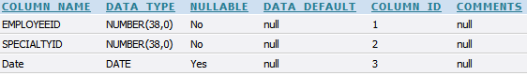

**NH_EMPSPEC Table Constraints**

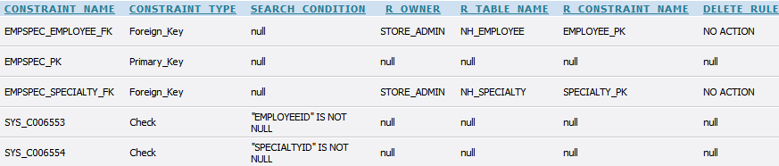

NH_EMPSPEC Creation, Population and Constraint Script

CREATE TABLE NH_EMPSPEC

(

EmployeeID INTEGER NOT NULL ,

SpecialtyID INTEGER NOT NULL ,

"Date" DATE

)

;

ALTER TABLE NH_EMPSPEC

ADD CONSTRAINT EmpSpec_PK PRIMARY KEY ( EmployeeID, SpecialtyID ) ;

/* EmployeeID INT, SpecialtyID INT, Date DATE */

INSERT INTO NH_EMPSPEC VALUES

(1, 1, '12-DEC-2011');

INSERT INTO NH_EMPSPEC VALUES (2, 1, '18-NOV-2011');

INSERT INTO NH_EMPSPEC VALUES (5, 4, '04-FEB-2012');

INSERT INTO NH_EMPSPEC VALUES (6, 10, '10-MAR-2012');

INSERT INTO NH_EMPSPEC VALUES (9, 8, '26-APR-2012');

INSERT INTO NH_EMPSPEC VALUES (6, 7, '27-OCT-2012');

INSERT INTO NH_EMPSPEC VALUES (5, 3, '23-NOV-2011');

INSERT INTO NH_EMPSPEC VALUES (7, 5, '12-OCT-2010');

INSERT INTO NH_EMPSPEC VALUES (3, 4, '05-JUN-2012');

INSERT INTO NH_EMPSPEC VALUES (4, 3, '12-DEC-2011');

INSERT INTO NH_EMPSPEC VALUES (5, 5, '12-NOV-2012');

INSERT INTO NH_EMPSPEC VALUES (6, 6, '12-MAR-2009');

INSERT INTO NH_EMPSPEC VALUES (9, 9, '15-APR-2008');

INSERT INTO NH_EMPSPEC VALUES (9, 3, '11-DEC-2010');

INSERT INTO NH_EMPSPEC VALUES (5, 2, '20-DEC-2008');

INSERT INTO NH_EMPSPEC VALUES (7, 7, '25-JAN-2011');

INSERT INTO NH_EMPSPEC VALUES (6, 3, '27-MAR-2011');

INSERT INTO NH_EMPSPEC VALUES (4, 8, '12-DEC-2007');

ALTER TABLE NH_EMPSPEC

ADD CONSTRAINT EmpSpec_Employee_FK FOREIGN KEY

(

EmployeeID

)

REFERENCES NH_EMPLOYEE

(

EmployeeID

)

;

ALTER TABLE NH_EMPSPEC

ADD CONSTRAINT EmpSpec_Specialty_FK FOREIGN KEY

(

SpecialtyID

)

REFERENCES NH_SPECIALTY

(

SpecialtyID

)

;

**NH_INVENTORY Table Structure**



**NH_INVENTORY Table Constraints**

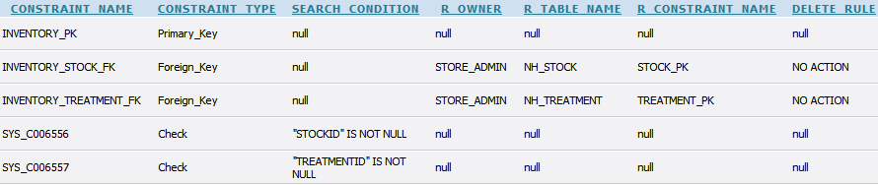

**NH_INVENTORY Table Creation, Population and Constraint Script**

CREATE TABLE NH_INVENTORY

(

StockID INTEGER NOT NULL ,

TreatmentID INTEGER NOT NULL

)

;

ALTER TABLE NH_INVENTORY

ADD CONSTRAINT Inventory_PK PRIMARY KEY ( TreatmentID, StockID ) ;

/* StockID INT, TreatmentID INT */

INSERT INTO NH_INVENTORY VALUES

(1, 1);

INSERT INTO NH_INVENTORY VALUES (2, 1);

INSERT INTO NH_INVENTORY VALUES (3, 4);

INSERT INTO NH_INVENTORY VALUES (4, 2);

INSERT INTO NH_INVENTORY VALUES (5, 12);

INSERT INTO NH_INVENTORY VALUES (6, 9);

INSERT INTO NH_INVENTORY VALUES (7, 8);

INSERT INTO NH_INVENTORY VALUES (8, 6);

INSERT INTO NH_INVENTORY VALUES (9, 4);

INSERT INTO NH_INVENTORY VALUES (10, 3);

INSERT INTO NH_INVENTORY VALUES (11, 3);

INSERT INTO NH_INVENTORY VALUES (12, 1);

ALTER TABLE NH_INVENTORY

ADD CONSTRAINT Inventory_Stock_FK FOREIGN KEY

(

StockID

)

REFERENCES NH_STOCK

(

StockID

)

;

ALTER TABLE NH_INVENTORY

ADD CONSTRAINT Inventory_Treatment_FK FOREIGN KEY

(

TreatmentID

)

REFERENCES NH_TREATMENT

(

TreatmentID

)

;

**NH_ORDER Table Structure**

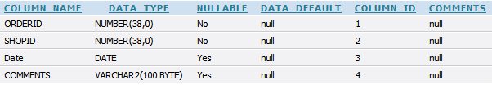

**NH_ORDER Table Constraints**

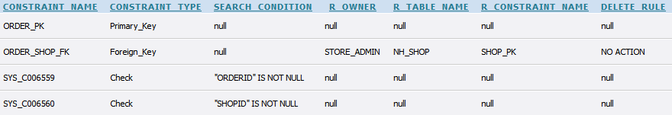

**NH_ORDER Table Creation, Population and Constraint Script**

CREATE TABLE NH_ORDER

(

OrderID INTEGER NOT NULL ,

ShopID INTEGER NOT NULL ,

"Date" DATE ,

Comments VARCHAR2 (100)

)

;

ALTER TABLE NH_ORDER

ADD CONSTRAINT Order_PK PRIMARY KEY ( OrderID ) ;

/* OrderID INT, ShopID INT, Date, DATE, Comments VARCHAR */

INSERT INTO NH_ORDER VALUES

(1, 1, '13-JUN-2000', 'Delivery before July please');

INSERT INTO NH_ORDER VALUES (2, 1, '22-FEB-2012', 'dont make a mess like last time');

INSERT INTO NH_ORDER VALUES (3, 3, '22-DEC-2011', 'URGENT! BEFORE CHRISTMAS!');

INSERT INTO NH_ORDER VALUES (4, 3, '23-DEC-2011', 'complementary to orderID 3');

INSERT INTO NH_ORDER VALUES (5, 4, '23-FEB-2011', 'one package broken last time, be careful');

INSERT INTO NH_ORDER VALUES (6, 6, '1-MAR-2011', 'before 10/3/2011 please');

INSERT INTO NH_ORDER VALUES (7, 7, '24-MAR-2011', 'Its a national holiday in Greece tomorrow, we will have visitors');

INSERT INTO NH_ORDER VALUES (8, 4, '04-APR-2011', 'Stock Refresh');

INSERT INTO NH_ORDER VALUES (9, 6, '05-MAY-2011', 'Ordinary Scheduled');

INSERT INTO NH_ORDER VALUES (10, 2, '04-JUN-2011', 'no comment');

INSERT INTO NH_ORDER VALUES (11, 4, '07-JUL-2011', 'mid summer stock refreshment');

INSERT INTO NH_ORDER VALUES (12, 7, '08-AUG-2011', 'just in case');

ALTER TABLE NH_ORDER

ADD CONSTRAINT Order_Shop_FK FOREIGN KEY

(

ShopID

)

REFERENCES NH_SHOP

(

ShopID

)

;

**NH_ORDERPRODUCT Table Structure**

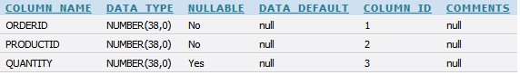

**NH_ORDERPRODUCT Table Constraints**

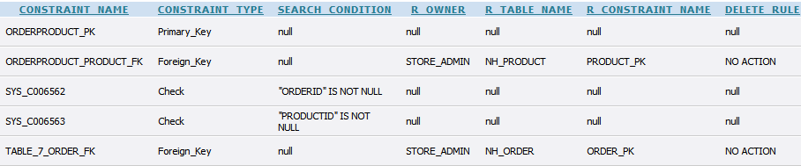

**NH_ORDERPRODUCT Table Creation, Population and Constraint Script**

CREATE TABLE NH_ORDERPRODUCT

(

OrderID INTEGER NOT NULL ,

ProductID INTEGER NOT NULL ,

Quantity INTEGER

)

;

ALTER TABLE NH_ORDERPRODUCT

ADD CONSTRAINT OrderProduct_PK PRIMARY KEY ( OrderID, ProductID ) ;

/* OrderID INT, ProductID INT, Quantity INT*/

INSERT INTO NH_ORDERPRODUCT VALUES

(1, 1, 3);

INSERT INTO NH_ORDERPRODUCT VALUES (12, 15, 5);

INSERT INTO NH_ORDERPRODUCT VALUES (11, 13, 6);

INSERT INTO NH_ORDERPRODUCT VALUES (1, 12, 8);

INSERT INTO NH_ORDERPRODUCT VALUES (4, 9, 4);

INSERT INTO NH_ORDERPRODUCT VALUES (6, 5, 15);

INSERT INTO NH_ORDERPRODUCT VALUES (3, 1, 8);

INSERT INTO NH_ORDERPRODUCT VALUES (2, 1, 7);

INSERT INTO NH_ORDERPRODUCT VALUES (6, 4, 23);

INSERT INTO NH_ORDERPRODUCT VALUES (7, 7, 35);

INSERT INTO NH_ORDERPRODUCT VALUES (2, 2, 8);

INSERT INTO NH_ORDERPRODUCT VALUES (8, 4, 23);

INSERT INTO NH_ORDERPRODUCT VALUES (10, 8, 15);

INSERT INTO NH_ORDERPRODUCT VALUES (11, 12, 32);

INSERT INTO NH_ORDERPRODUCT VALUES (9, 4, 1);

INSERT INTO NH_ORDERPRODUCT VALUES (4, 5, 5);

INSERT INTO NH_ORDERPRODUCT VALUES (5, 7, 80);

INSERT INTO NH_ORDERPRODUCT VALUES (2, 4, 16);

ALTER TABLE NH_ORDERPRODUCT

ADD CONSTRAINT OrderProduct_Product_FK FOREIGN KEY

(

ProductID

)

REFERENCES NH_PRODUCT

(

ProductID

)

;

**NH_PRODSUP Table Structure**

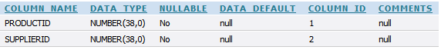

**NH_PRODSUP Table Constraints**

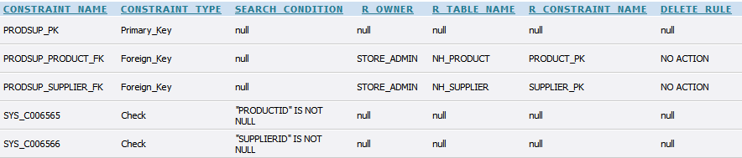

**NH_PRODSUP Table Creation, Population and Constraint Script**

CREATE TABLE NH_PRODSUP

(

ProductID INTEGER NOT NULL ,

SupplierID INTEGER NOT NULL

)

;

ALTER TABLE NH_PRODSUP

ADD CONSTRAINT ProdSup_PK PRIMARY KEY ( ProductID, SupplierID ) ;

/* ProductID INT, SupplierID INT */

INSERT INTO NH_PRODSUP VALUES

(1, 1);

INSERT INTO NH_PRODSUP VALUES (1, 2);

INSERT INTO NH_PRODSUP VALUES (2, 2);

INSERT INTO NH_PRODSUP VALUES (1, 5);

INSERT INTO NH_PRODSUP VALUES (1, 6);

INSERT INTO NH_PRODSUP VALUES (5, 1);

INSERT INTO NH_PRODSUP VALUES (8, 1);

INSERT INTO NH_PRODSUP VALUES (1, 7);

INSERT INTO NH_PRODSUP VALUES (3, 1);

INSERT INTO NH_PRODSUP VALUES (6, 8);

INSERT INTO NH_PRODSUP VALUES (4, 3);

INSERT INTO NH_PRODSUP VALUES (7, 1);

INSERT INTO NH_PRODSUP VALUES (8, 8);

INSERT INTO NH_PRODSUP VALUES (7, 6);

INSERT INTO NH_PRODSUP VALUES (3, 4);

INSERT INTO NH_PRODSUP VALUES (2, 6);

INSERT INTO NH_PRODSUP VALUES (10, 11);

ALTER TABLE NH_PRODSUP

ADD CONSTRAINT ProdSup_Product_FK FOREIGN KEY

(

ProductID

)

REFERENCES NH_PRODUCT

(

ProductID

)

;

ALTER TABLE NH_PRODSUP

ADD CONSTRAINT ProdSup_Supplier_FK FOREIGN KEY

(

SupplierID

)

REFERENCES NH_SUPPLIER

(

SupplierID

)

;

**NH_PRODUCT Table Structure**

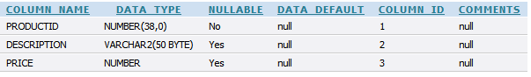

**NH_PRODUCT Table Constraints**

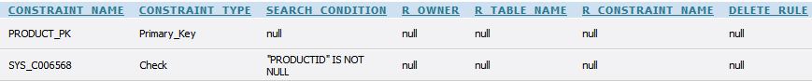

**NH_PRODUCT Table Creation, Population and Constraint Script**

CREATE TABLE NH_PRODUCT

(

ProductID INTEGER NOT NULL ,

Description VARCHAR2 (50) ,

Price NUMBER

)

;

ALTER TABLE NH_PRODUCT

ADD CONSTRAINT Product_PK PRIMARY KEY ( ProductID ) ;

/* ProductID INT, Desc VARCHAR, Price NUMBER (DECIMAL) */

INSERT INTO NH_PRODUCT VALUES

(1, 'ahughes co', 15);

INSERT INTO NH_PRODUCT VALUES (2, 'Amazon Hair', 13.2);

INSERT INTO NH_PRODUCT VALUES (3, 'Latex Gloves', 2.7);

INSERT INTO NH_PRODUCT VALUES (4, 'Premium Lotion', 22.75);

INSERT INTO NH_PRODUCT VALUES (5, 'Ultra Premium Lambda Olive Oil', 49.99);

INSERT INTO NH_PRODUCT VALUES (6, 'Syringe', 3.7);

INSERT INTO NH_PRODUCT VALUES (7, 'My Lucky One', 11.7);

INSERT INTO NH_PRODUCT VALUES (8, 'Massage Underwear', 0.75);

INSERT INTO NH_PRODUCT VALUES (9, 'Massage Slippers', 1.99);

INSERT INTO NH_PRODUCT VALUES (10, 'Hair Protector', 0.5);

INSERT INTO NH_PRODUCT VALUES (11, 'Natural Hair Conditioner', 9.99);

INSERT INTO NH_PRODUCT VALUES (12, 'Natural Hair Shampoo', 4.99);

INSERT INTO NH_PRODUCT VALUES (13, 'Relaxing Herbs', 3.99);

INSERT INTO NH_PRODUCT VALUES (14, 'Natural Painkillers', 6.78);

INSERT INTO NH_PRODUCT VALUES (15, 'Valerian Relaxing Pills', 3.98);

**NH_ROOM Table Structure**

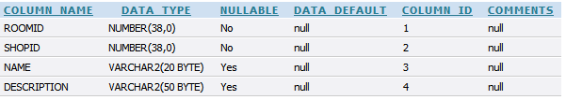

**NH_ROOM Table Constraints**

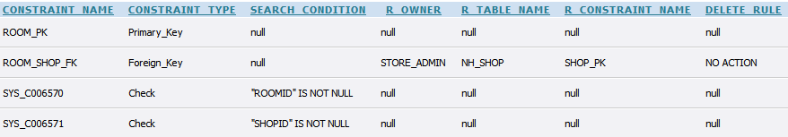

**NH_ROOM Table Creation, Population and Constraint Script**

CREATE TABLE NH_ROOM

(

RoomID INTEGER NOT NULL ,

ShopID INTEGER NOT NULL ,

Name VARCHAR2 (20) ,

Description VARCHAR2 (50)

)

;

ALTER TABLE NH_ROOM

ADD CONSTRAINT Room_PK PRIMARY KEY ( RoomID ) ;

/* RoomID INT, ShopID INT, Name VARCHAR, Desc VARCHAR */

INSERT INTO NH_ROOM VALUES

(1, 1, 'G.01','Comfy');

INSERT INTO NH_ROOM VALUES (2, 1, 'G.02','Richmans');

INSERT INTO NH_ROOM VALUES (3, 1, 'F.01','Cozy');

INSERT INTO NH_ROOM VALUES (4, 2, 'G.01','Jubilee');

INSERT INTO NH_ROOM VALUES (5, 3, 'G.01','Estate');

INSERT INTO NH_ROOM VALUES (6, 3, 'G.02','Mansion');

INSERT INTO NH_ROOM VALUES (7, 5, 'E.12','Hand King');

INSERT INTO NH_ROOM VALUES (8, 5, 'E.13','Foot King');

INSERT INTO NH_ROOM VALUES (9, 5, 'F.12','21st century');

INSERT INTO NH_ROOM VALUES (10, 6, 'G.01','Ergonomic');

INSERT INTO NH_ROOM VALUES (11, 7, '117','Body Temple');

INSERT INTO NH_ROOM VALUES (12, 7, '116','Physical Miracle');

INSERT INTO NH_ROOM VALUES (13, 3, '1.01','Illumination');

ALTER TABLE NH_ROOM

ADD CONSTRAINT Room_Shop_FK FOREIGN KEY

(

ShopID

)

REFERENCES NH_SHOP

(

ShopID

)

;

**NH_SHOP Table Structure**

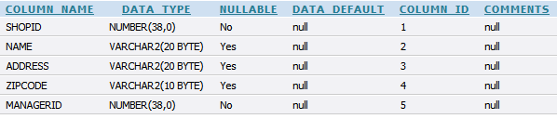

**NH_SHOP Table Constraints**

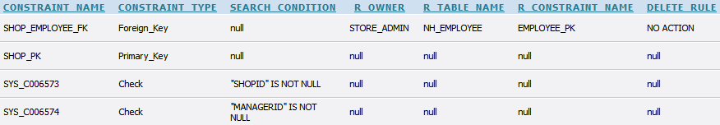

**NH_SHOP Table Creation, Population and Constraint Script**

CREATE TABLE NH_SHOP

(

ShopID INTEGER NOT NULL ,

Name VARCHAR2 (20) ,

Address VARCHAR2 (20) ,

ZipCode VARCHAR2 (10) ,

ManagerID INTEGER NOT NULL

)

;

ALTER TABLE NH_SHOP

ADD CONSTRAINT Shop_PK PRIMARY KEY ( ShopID ) ;

/* ShopID INT, Name VARCHAR, Address VARCHAR, Zip_Code VARCHAR, ManagerID INT*/

INSERT INTO NH_SHOP VALUES

(1, 'aShopName', 'anAddress', 'aZip_Code', 2);

INSERT INTO NH_SHOP VALUES (2,'Bling','74 Addle Hill','E12 kiu', 4);

INSERT INTO NH_SHOP VALUES (3,'Sexy SPA','19 Abchurch Yard','nw2 cfr', 8);

INSERT INTO NH_SHOP VALUES (4,'The Hot Stop','95 Addle Street','s2 6za', 10);

INSERT INTO NH_SHOP VALUES (5,'Relaxing','64Cutler Street','sw1 2lo', 11);

INSERT INTO NH_SHOP VALUES (6,'Abbey','9 Cursitor Street','e13 98h', 14);

INSERT INTO NH_SHOP VALUES (7,'Holy Bacon','45 Amen Corner ','n9 9np', 15);

ALTER TABLE NH_SHOP

ADD CONSTRAINT Shop_Employee_FK FOREIGN KEY

(

ManagerID

)

REFERENCES NH_EMPLOYEE

(

EmployeeID

)

;

**NH_SPECIALTY Table Structure**



**NH_SPECIALTY Table Constraints**



**NH_SPECIALTY Table Creation, Population and Constraint Script**

CREATE TABLE NH_SPECIALTY

(

SpecialtyID INTEGER NOT NULL ,

Description VARCHAR2 (50)

)

;

ALTER TABLE NH_SPECIALTY

ADD CONSTRAINT Specialty_PK PRIMARY KEY ( SpecialtyID ) ;

/*SpecialtyID INT, Description VARCHAR */

INSERT INTO NH_SPECIALTY VALUES

(1, 'Head Massage');

INSERT INTO NH_SPECIALTY VALUES (2, 'Neck Massage');

INSERT INTO NH_SPECIALTY VALUES (3, 'Music and Aura Relaxation');

INSERT INTO NH_SPECIALTY VALUES (4, 'Full Body Massage');

INSERT INTO NH_SPECIALTY VALUES (5, 'Body Scrub');

INSERT INTO NH_SPECIALTY VALUES (6, 'Face Scrub');

INSERT INTO NH_SPECIALTY VALUES (7, 'Dry Hair Treatment');

INSERT INTO NH_SPECIALTY VALUES (8, 'Curls and Head Scrub');

INSERT INTO NH_SPECIALTY VALUES (9, 'Dry Skin Treatment');

INSERT INTO NH_SPECIALTY VALUES (10, 'Psoriasis Treatment');

INSERT INTO NH_SPECIALTY VALUES (11, 'Reiki Massage');

INSERT INTO NH_SPECIALTY VALUES (12, 'Nail Polishing');

**NH_STOCK Table Structure**

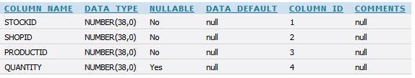

**NH_STOCK Table Constraints**

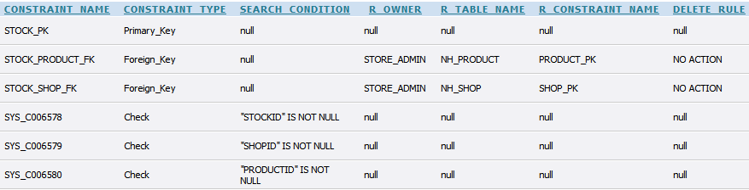

**NH_STOCK Table Creation, Population and Constraint Script**

CREATE TABLE NH_STOCK

(

StockID INTEGER NOT NULL ,

ShopID INTEGER NOT NULL ,

ProductID INTEGER NOT NULL ,

Quantity INTEGER

)

;

ALTER TABLE NH_STOCK

ADD CONSTRAINT Stock_PK PRIMARY KEY ( StockID ) ;

/* StockID INT, ShopID INT, ProductID INT, Quantity INT */

INSERT INTO NH_STOCK VALUES

(1, 1, 1, 15);

INSERT INTO NH_STOCK VALUES (2, 1, 12, 12);

INSERT INTO NH_STOCK VALUES (3, 1, 14, 4);

INSERT INTO NH_STOCK VALUES (4, 3, 3, 3);

INSERT INTO NH_STOCK VALUES (5, 3, 10, 4);

INSERT INTO NH_STOCK VALUES (6, 4, 9, 2);

INSERT INTO NH_STOCK VALUES (7, 6, 15, 14);

INSERT INTO NH_STOCK VALUES (8, 7, 1, 10);

INSERT INTO NH_STOCK VALUES (9, 7, 2, 4);

INSERT INTO NH_STOCK VALUES (10, 5, 12, 12);

INSERT INTO NH_STOCK VALUES (11, 2, 14, 4);

INSERT INTO NH_STOCK VALUES (12, 1, 3, 3);

INSERT INTO NH_STOCK VALUES (13, 3, 4, 5);

INSERT INTO NH_STOCK VALUES (14, 5, 13, 4);

INSERT INTO NH_STOCK VALUES (15, 1, 4, 5);

ALTER TABLE NH_STOCK

ADD CONSTRAINT Stock_Product_FK FOREIGN KEY

(

ProductID

)

REFERENCES NH_PRODUCT

(

ProductID

)

;

ALTER TABLE NH_STOCK

ADD CONSTRAINT Stock_Shop_FK FOREIGN KEY

(

ShopID

)

REFERENCES NH_SHOP

(

ShopID

)

;

**NH_SUPPLIER Table Structure**

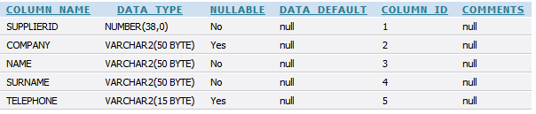

**NH_SUPPLIER Table Constraints**

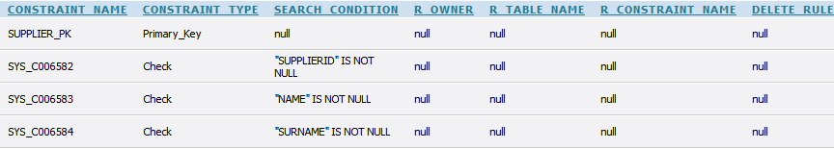

**NH_SUPPLIER Table Creation, Population and Constraint Script**

CREATE TABLE NH_SUPPLIER

(

SupplierID INTEGER NOT NULL ,

Company VARCHAR2 (50) ,

Name VARCHAR2 (50) NOT NULL ,

Surname VARCHAR2 (50) NOT NULL ,

Telephone VARCHAR2 (15)

)

;

ALTER TABLE NH_SUPPLIER

ADD CONSTRAINT Supplier_PK PRIMARY KEY ( SupplierID ) ;

/* SupplierID INT, Company VARCHAR, Name VARCHAR, Surname VARCHAR, Telephone VARCHAR */

INSERT INTO NH_SUPPLIER VALUES

(1, 'HeadCare', 'Jack', 'Lee', '07908878547');

INSERT INTO NH_SUPPLIER VALUES (2, 'HandLove', 'Red', 'Clif', '07505512336');

INSERT INTO NH_SUPPLIER VALUES (3, 'FootLook', 'Kelly', 'Kent', '020874121458');

INSERT INTO NH_SUPPLIER VALUES (4, 'BodyCare', 'Jeff', 'Kent', '07814777874');

INSERT INTO NH_SUPPLIER VALUES (5, 'LookGood', 'Jimmy', 'Jay', '02085477777');

INSERT INTO NH_SUPPLIER VALUES (6, 'FirstWax', 'Ian', 'Beat', '079022121456');

INSERT INTO NH_SUPPLIER VALUES (7, 'Cleaning', 'Ken', 'Naz', '020836987451');

INSERT INTO NH_SUPPLIER VALUES (8, 'Marks and Spencer', 'Melinda', 'Belius', '0759874521');

INSERT INTO NH_SUPPLIER VALUES (9, 'Dont judge our name', 'George', 'Jack-the-Elfs', '07569874521');

INSERT INTO NH_SUPPLIER VALUES (10, 'Lousy Cleaning', 'George', 'Lazyman', '0756594521');

INSERT INTO NH_SUPPLIER VALUES (11, 'Croco-Skin', 'Sting', 'Tooth', '07569874521');

**NH_SUPSHOP Table Structure**

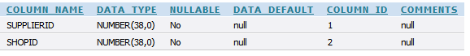

**NH_SUPSHOP Table Constraints**

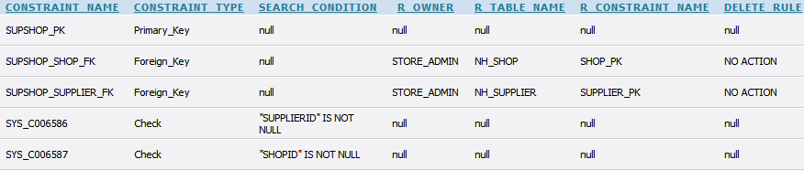

**NH_SUPSHOP Table Creation, Population and Constraint Script**

CREATE TABLE NH_SUPSHOP

(

SupplierID INTEGER NOT NULL ,

ShopID INTEGER NOT NULL

)

;

ALTER TABLE NH_SUPSHOP

ADD CONSTRAINT SupShop_PK PRIMARY KEY ( SupplierID, ShopID ) ;

/* SupplierID INT, ShopID INT */

INSERT INTO NH_SUPSHOP VALUES

(1, 1);

INSERT INTO NH_SUPSHOP VALUES (11, 5);

INSERT INTO NH_SUPSHOP VALUES (11, 1);

INSERT INTO NH_SUPSHOP VALUES (1, 6);

INSERT INTO NH_SUPSHOP VALUES (6, 2);

INSERT INTO NH_SUPSHOP VALUES (4, 2);

INSERT INTO NH_SUPSHOP VALUES (5, 4);

INSERT INTO NH_SUPSHOP VALUES (5, 6);

INSERT INTO NH_SUPSHOP VALUES (6, 3);

INSERT INTO NH_SUPSHOP VALUES (1, 7);

INSERT INTO NH_SUPSHOP VALUES (2, 1);

INSERT INTO NH_SUPSHOP VALUES (6, 4);

INSERT INTO NH_SUPSHOP VALUES (4, 3);

INSERT INTO NH_SUPSHOP VALUES (10, 7);

INSERT INTO NH_SUPSHOP VALUES (10, 5);

INSERT INTO NH_SUPSHOP VALUES (5, 1);

INSERT INTO NH_SUPSHOP VALUES (2, 2);

INSERT INTO NH_SUPSHOP VALUES (9, 5);

ALTER TABLE NH_SUPSHOP

ADD CONSTRAINT SupShop_Shop_FK FOREIGN KEY

(

ShopID

)

REFERENCES NH_SHOP

(

ShopID

)

;

ALTER TABLE NH_SUPSHOP

ADD CONSTRAINT SupShop_Supplier_FK FOREIGN KEY

(

SupplierID

)

REFERENCES NH_SUPPLIER

(

SupplierID

)

;

**NH_TREATMENT Table Structure**

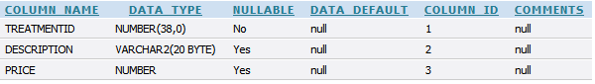

**NH_TREATMENT Table Constraints**



**NH_TREATMENT Table Creation, Population and Constraint Script**

CREATE TABLE NH_TREATMENT

(

TreatmentID INTEGER NOT NULL ,

Description VARCHAR2 (20) ,

Price NUMBER

)

;

ALTER TABLE NH_TREATMENT

ADD CONSTRAINT Treatment_PK PRIMARY KEY ( TreatmentID ) ;

/* TreatmentID INT, Desc VARCHAR, Price DECIMAL */

INSERT INTO NH_TREATMENT VALUES

(1, 'Head Care', 15);

INSERT INTO NH_TREATMENT VALUES (2, 'Foot Massage', 8.88);

INSERT INTO NH_TREATMENT VALUES (3, 'Full Body Massage', 30);

INSERT INTO NH_TREATMENT VALUES (4, 'Hair Loss Treatment', 100);

INSERT INTO NH_TREATMENT VALUES (5, 'Leg Wax and Care', 20);

INSERT INTO NH_TREATMENT VALUES (6, 'Spanish Massage', 55);

INSERT INTO NH_TREATMENT VALUES (7, 'Face Massage', 15);

INSERT INTO NH_TREATMENT VALUES (8, 'Face Scrub', 18);

INSERT INTO NH_TREATMENT VALUES (9, 'Voice Therapy', 70);

INSERT INTO NH_TREATMENT VALUES (10, 'Head Massage', 40);

INSERT INTO NH_TREATMENT VALUES (11, 'Body Scrub', 60);

INSERT INTO NH_TREATMENT VALUES (12, 'Stress Therapy', 28.99);

INSERT INTO NH_TREATMENT VALUES (13, 'Full Body Massage', 50);

# 1.6 PL/SQL

# 1.7 Implementation

Here are some implementation which we have done using PL/SQL in our Database management system (DBMS).

**Trigger**:

**Function**:

**Procedure**:

**Cursor**:

# 1.8 Showing the Queries

**4. Can you list all the staff names and their manager’s name, for a particular shop?**

SELECT E.Name AS Emp_Name, E.Surname AS Emp_Surname,

M.Name AS Manager_Name, M.Surname AS Manager_Surname,

S.ShopID, S.Address

FROM NH_EMPLOYEE M, NH_EMPLOYEE E

INNER JOIN NH_SHOP S ON S.ShopID = E.ShopID

WHERE S.ManagerID = M.EmployeeID AND S.ShopID = 2;

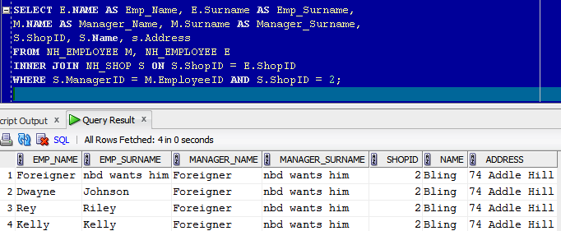

**5. Can you list all the sessions a specific member of staff had on a specific day, which**

**customers and the room numbers?**

SELECT B.BookingID, B."Date", C.Name, C.Surname, R.RoomID,

R.Name AS Room_Name

FROM NH_BOOKING B

INNER JOIN NH_EMPLOYEE E ON E.EmployeeID = B.EmployeeID

INNER JOIN NH_ROOM R ON R.RoomID = B.RoomID

INNER JOIN NH_CUSTOMER C ON C.CustomerID = B.CustomerID

WHERE E.EmployeeID = 5 AND B."Date" = '11-JUL-11';

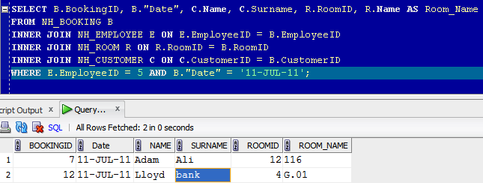

**6. A customer could ask ‘Which member of staff did my 9-10 session today and can you tell me who their manager is because I want to complain?’**

# 1.9 Group Member Participation

Within our group we had people with some strengths and weaknesses who played a big part on the development of the database management system. We will try to present and report for some problems we had during this assignment.

Firstly let’s talk about the group members participation within the group.

Talking about **Mohammod Habibur Rahman (ID: u10080150)**, he is a very hard working person, he does a lot of research and he is very committed to his work and to his group team. He is one of them guys which will stay late to make sure that the DBMS is the best it could be within the team. This is a very strong attribute from Habib, however everyone has his own weakness, and for Habib his main weakness is that he has a disability which it hard for him some of the time to spell words. He’s dyslexic and this is one of his weaknesses; however this did not stop him from giving his most best 100% of the time while developing this system for the company. Another thing which I needed to develop on before I could really help out in the project was to expand my own key knowledge of database system and how to write simple PL/SQL. Once I did his I could start coding some of the database system for the company.

Apart from this one weakness which he has, his work which he has put in must be recognition as he has work as hard as he can to try and make this DBMS as best as possible as it can be. I cannot really say anything negative about this person as he is always the first to come in and the last to leave.

We both took turns in developing the database system as we both had to gain some new skills into learning PL/SQL. The way we went about this was to research a little about how to write PL/SQL before starting to develop the database management system for the company. Once we had learnt the PL/SQL we then had to expand our knowledge into database system in order to make the system function to the best of its ability.

Another aspect of the project which me and my group partner did was running the test on the database system to make sure that the system which was developed ran as smoothly as possible.

The second member of the group is **Alexandros Akrivopoulos-Hughes (ID: u1235441)**. The database coding was done by both of us. Both of us help each other to make sure that when we were developing the database system we used each other skills sets to achieve our main object.

My group member was the chief architect in designing the ER1 logical diagram, along with engineering it to ER2 relational diagram. He proposed sample diagrams commenting about possible problems that may arise from each of them and we both chose the best for the job.

My group member also did the most of the coding for creating the embedded business logic for the database. I had some skills in PL/SQL; however my group member had a better understanding of the big picture when it comes to PL/SQL. Therefore he was the one that designed the business logic functionality for the database but we both were charged with developing it.

These are the few things which we have done within the group. We were meeting up at least once a week to catch up and report for our progress and also make some decisions about the projects working flow. Within the group we had to understand each other’s strengths and weaknesses to make sure that each one of us was capable of delivering high quality work, so that the overall database solution was of high quality.

# 2.0 Evaluation

We were given a case study whereby we had to develop a database management system to help a company’s booking policy as well as stock management. The database system must be developed to help this company to minimize their errors in order to maximize their profits.

Once the ER1 logical diagram was created after brainstorming and merging proposed solutions from team members, we started testing it by creating real time scenarios and questions that the diagram should have the ability to answer.

After creating a proper logical model, we only had to import it and pass it to the right tools and the ER2 relational model was just a matter of time to construct, test and finalize. However, checking, modelling and implementing all the constraints takes time and energy.

After the ER2 relational model was made completely, it was really easy to make the database creation script, as well as some sample test data. We moved on with that and we had the ability of already answering the questions that have been asked to us, after constructing the right queries.

The other time consuming part was writing the PL/SQL for embedding the business logic into the database, because it was a bit new to every member of the team and we spent some time learning and experimenting with its advantages, disadvantages and capabilities.

In the end, business logic was also coded and shipped along with the database product and it really enhanced the product’s operation as it stopped double bookings, applied automatically discounts etc.

# 2.1 Recommendation

If we had more time we both think that we could have learnt much more of PL/SQL and we would have tried to develop an enhanced database system for the company. However, according to the time given and the workload of our everyday lives, the system was really complete and stable, as we really made use of our available time and optimized the development process by increasing our productivity, using the right tools for the job.

Overall we can both say that our group gained a lot of experience and also learn new things, concepts, ideas and methodologies during this assignment.

2.2 References:

[1] Thomas, C. and Carolyn, B. (2008), Database Systems A Practical Approach to Design, Implementation, and Management, 5th ed. (Accessed 11.02.2012)

[2] Thomas, C. and Carolyn, B. (2010), Database system Database Systems a Practical Approach to Design, Implementation, and Management (Accessed 15.02.2012)

[3] Andy, O. (2004), Database, a self teaching guide, (Accessed 16.02.2012)